**Analysing Data Distributions using Graphical Representations**

|  |
| --- |
| **Directions** |

* **3 min -** Read the first scenario in your group and study the graphical representation to answer the two questions that follow.
* **15 min -** Repeat for the remaining scenarios.

|  |
| --- |
| **Scenario 1** |

A data analyst at a retail store tracks the monthly sales over the past year and presents it at the annual strategy meeting.

**Data:**

|  |  |  |  |  |  |  |  |  |  |  |  |  |
| --- | --- | --- | --- | --- | --- | --- | --- | --- | --- | --- | --- | --- |
| **Month** | Jan | Feb | Mar | Apr | May | Jun | Jul | Aug | Sep | Oct | Nov | Dec |
| **Sales** | 1200 | 1350 | 1280 | 1420 | 1500 | 1480 | 1580 | 1600 | 1550 | 1620 | 1700 | 1650 |

**Graphical Representation:**

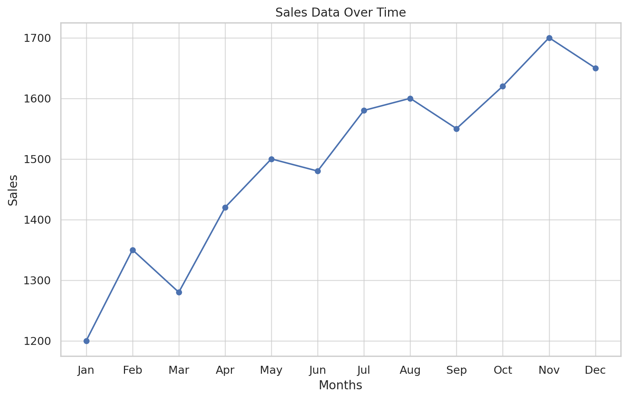

**Questions**:

1. What type of graphical representation is this? Line chart
2. What pattern do you observe in the sales trend over the year? Sales is going high

|  |
| --- |
| **Scenario 2** |

A company asks the Data Analyst to compare sales of three products (A, B, C) over four quarters.

**Data:**

|  |  |  |  |
| --- | --- | --- | --- |
| **Quarter** | **Product A** | **Product B** | **Product C** |
| Q1 | 300 | 350 | 220 |
| Q2 | 320 | 400 | 225 |
| Q3 | 290 | 450 | 230 |
| Q4 | 310 | 500 | 228 |

**Graphical Representation:**

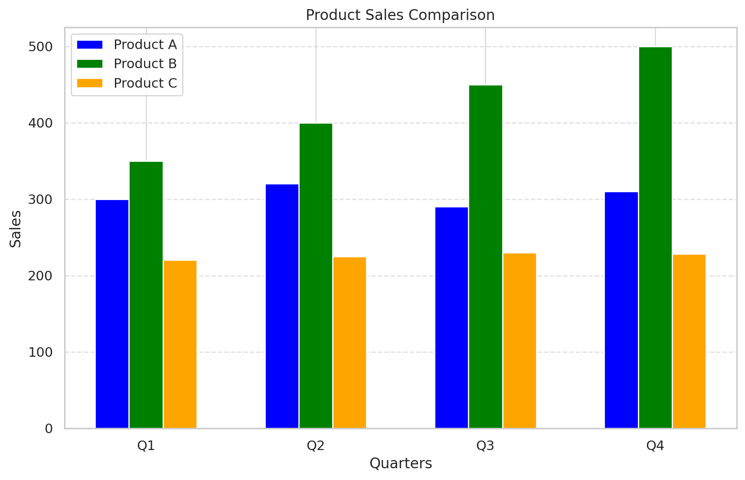

**Questions**:

1. What type of graphical representation is this? Column chart
2. Which product had the most consistent sales? C is consistent

|  |
| --- |
| **Scenario 3** |

A Data Analyst was working on tracking the market share distribution among four competitors in the tech industry. This is the representation they came up with for the analysed data.

**Data:**

|  |  |
| --- | --- |
| **Company** | **Market Share (%)** |
| Company A | 30 |
| Company B | 25 |
| Company C | 20 |
| Company D | 25 |

**Graphical Representation:**

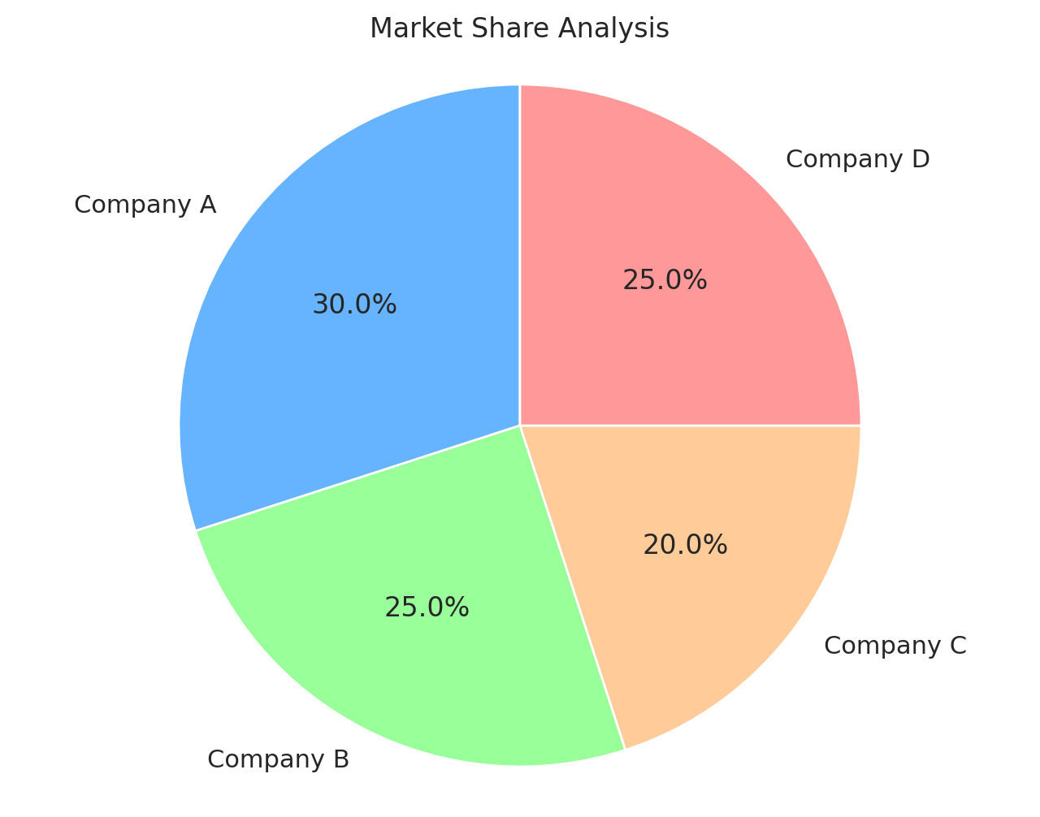

**Questions**:

1. What type of graphical representation is this? Pie chart
2. What does it reveal about the market competition? Company A has more market share, B and D are competitive

|  |
| --- |
| **Scenario 4** |

A sports nutrition company planning to launch a new protein bar requests the Data Analyst to analyse the age distribution of their current customer base. The data shows how frequently customers of different age groups purchase from their brand, providing insights into their target market

**Data:**

|  |  |  |  |  |  |  |
| --- | --- | --- | --- | --- | --- | --- |
| **Age Range** | 18-25 | 26-35 | 36-45 | 46-55 | 56-65 | 66+ |
| **Frequency** | 15 | 40 | 30 | 20 | 10 | 5 |

**Graphical Representation:**

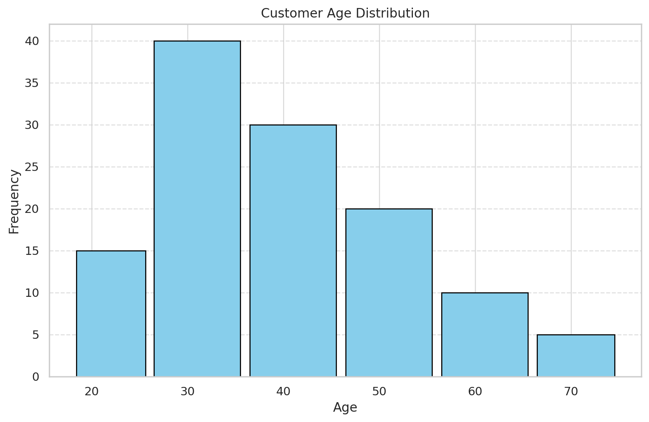

**Questions**: ,

1. What type of graphical representation is this? Histogram, Age bins
2. What does it tell you about the most common age group? 30

|  |
| --- |
| **Scenario 5** |

A new online store wants to understand the relationship between website traffic and sales. Their Data Analyst prepares this visualisation using available data.

**Data:**

|  |  |  |  |  |  |  |
| --- | --- | --- | --- | --- | --- | --- |
| **Traffic (in thousands)** | 10 | 15 | 20 | 25 | 30 | 35 |
| **Sales ($)** | 500 | 700 | 850 | 950 | 1050 | 1100 |

**Graphical Representation:**

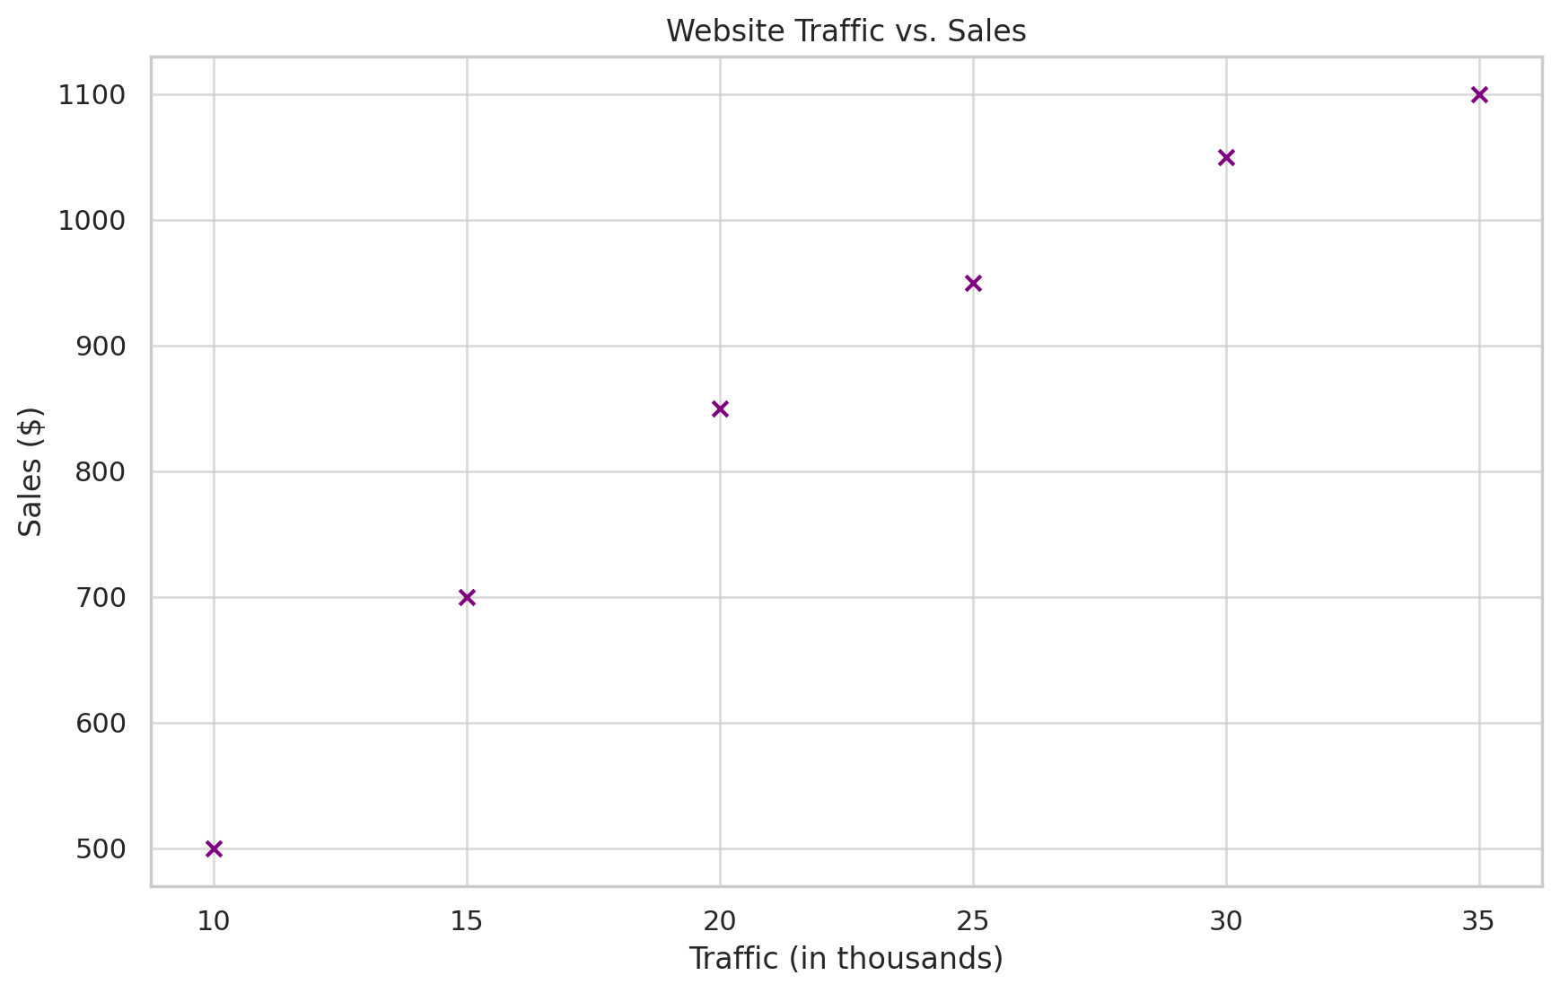

**Questions**:

1. What type of graphical representation is this? Scatter plot
2. What does it reveal about the relationship between traffic and sales? As the sales increase, traffic increases. Positive correlation between two

|  |
| --- |
| **Scenario 6** |

A retail company is reviewing the performance scores of its employees across different departments: HR, Sales, Marketing, and IT. The management asks the Data Analyst to help them understand which department shows the most variability in performance to identify areas needing consistent training and support.

**Data:**

|  |  |
| --- | --- |
| **Department** | **Scores** |
| HR | 70, 72, 74, 75, 77... |
| Sales | 65, 67, 70, 72, 75... |
| Marketing | 68, 70, 72, 74, 76... |
| IT | 72, 74, 75, 77, 79... |

**Graphical Representation:**

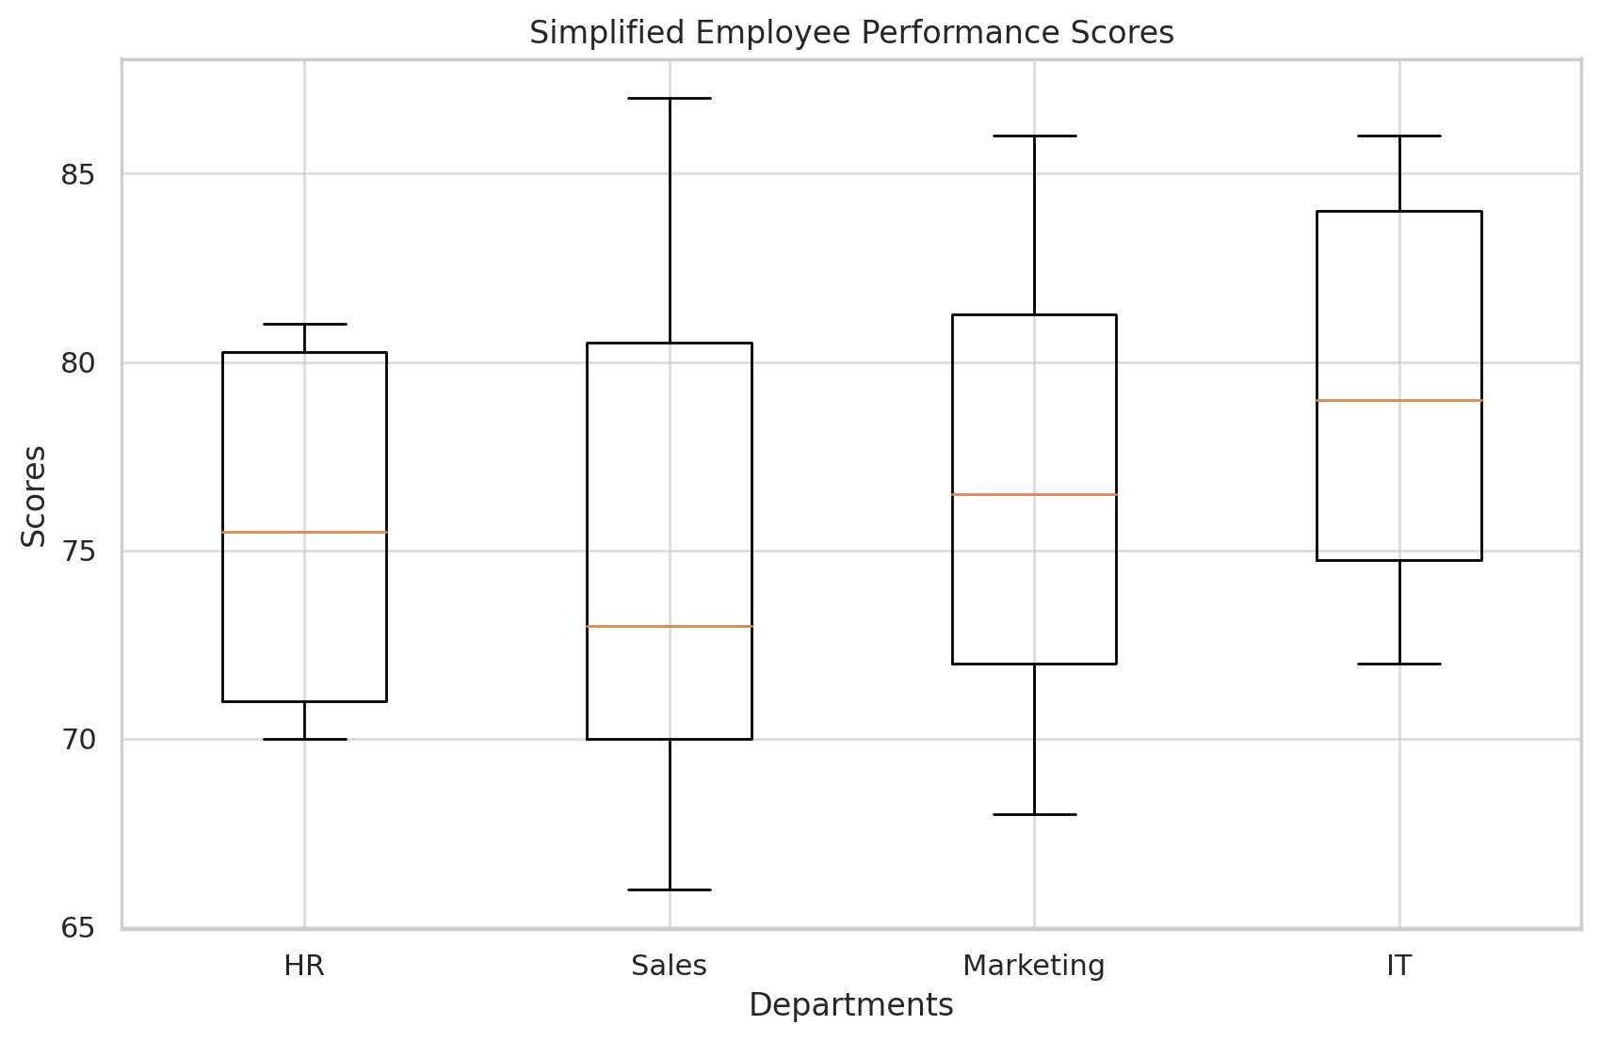

**Questions**:

1. What type of graphical representation is this? Box chart
2. Which department has the highest variation of scores? How can you tell by looking at the image? Sales department. Variation is high between

A box plot visually represents the distribution of data, showing:

* The **median** (middle value)
* The **upper and lower quartiles** (Q3 and Q1)
* The **range** (minimum and maximum values)